# Procedure for depositing information on the server of the Theia/OZCAR information system

An authenticated http data repository has been set up under an Apache server to set up the information flows between the data producers' information systems and the Theia/OZCAR information system.

Each observatory has a repository directory. The data must be deposited as a zip archive containing itself the pivot format.json file and the zip archives with the data files. The name the zip archive does not matter ( ex: MSEC_THEIA.zip).

*Example of the content of the MSEC_THEIA.zip archive.*

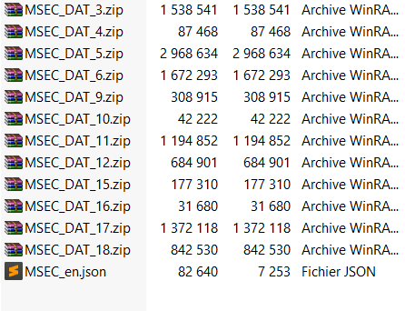

*The archive contains the information of the pivot model (MSEC_en.json file) as well as the data related to each of the data sets of the data producer (each.zip archive contains the data of a data set).*

The.zip archive can be dropped on the command line server as follows:

**curl -k -u "producerId":"password" -T /chemin/vers/le/.zip** [**https://in-situ.theia-land.fr/data/**](https://in-situ.theia-land.fr/data/)[**"producerId"/new/**](https://in-situ.theia-land.fr/data/"producerId"/new/)

***producerId :*** *4 letters identifying uniquely the data producer*

***password:*** *please contact us when the information is ready to be submitted to recover the password.*

*The previous deposited archive is visible under* [***https://in-situ.theia-land.fr/data/***](https://in-situ.theia-land.fr/data/)[***"producerId"/***](https://in-situ.theia-land.fr/data/"producerId"/previous/)***previous/***